Name:

ID:

Assignment 12-08-2020

Submit assignment here: <https://docs.google.com/forms/d/e/1FAIpQLSfpbnV_mEUXpMgagyrqLIfUtpq4olWAhxrfqjhKx2k-1OaBcA/viewform>

JSFiddle: <https://jsfiddle.net/>

Book: <http://runestone.academy/runestone/books/published/webfundamentals/CSS/toctree.html>

Part 1: Web Programming Examples

1. Consider the following CSS and HTML:

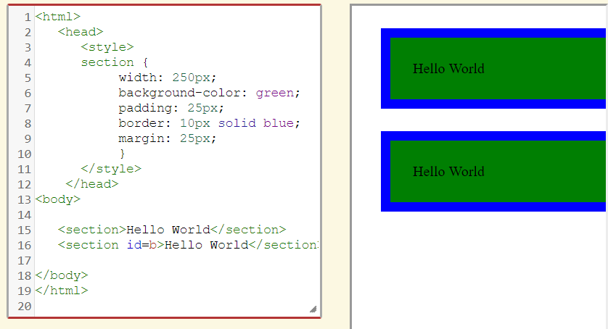

* How can I change the size of the green rectangles?
* What if I want the green rectangles to be gold?
* How can the blue rectangles become smaller and orange?
* How can you increase the space between the rectangles?

1. Consider the following HTML and CSS:

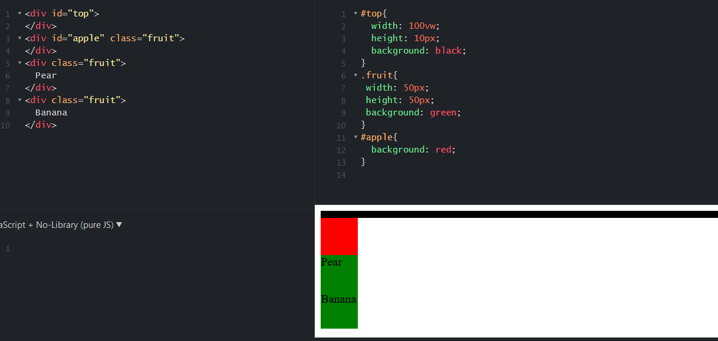

* Change 100vw to 50vw and background: green to background: gold, paste screenshot below:

1. Consider the following HTML and CSS:

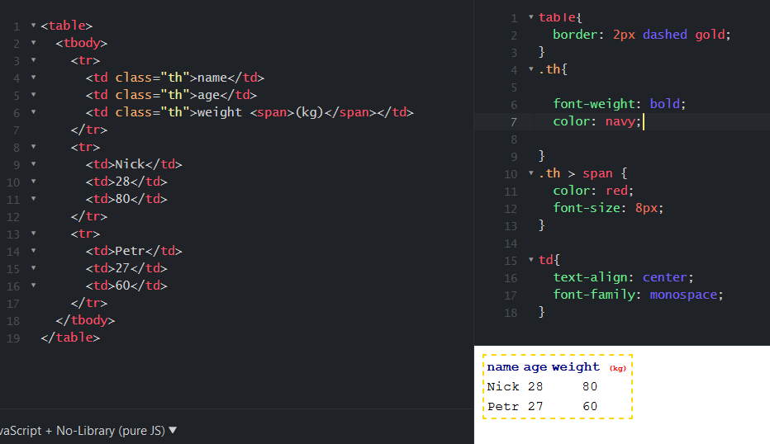

1. Consider the following HTML, JavaScript, and CSS:

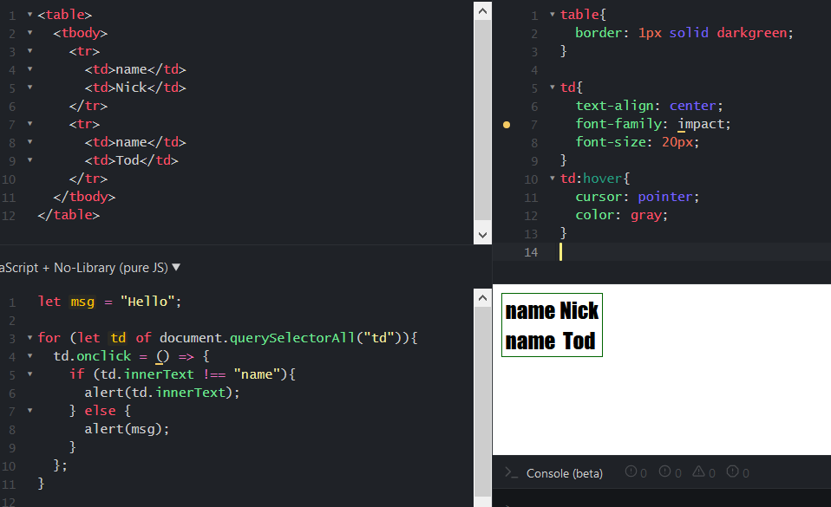

* Change the code so that every time the user clicks name, the alert “freedom” is generated.
* Change the code so that when the user hovers over a td element, the color changes to pink.

1. Consider the following HTML, JavaScript, and CSS:

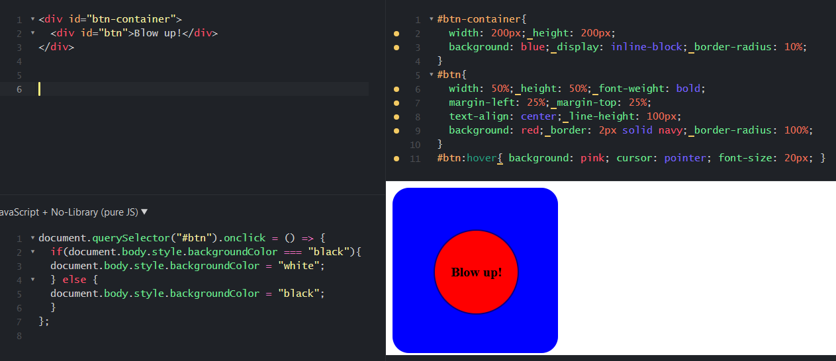

1. Consider the following HTML, JavaScript, and CSS:

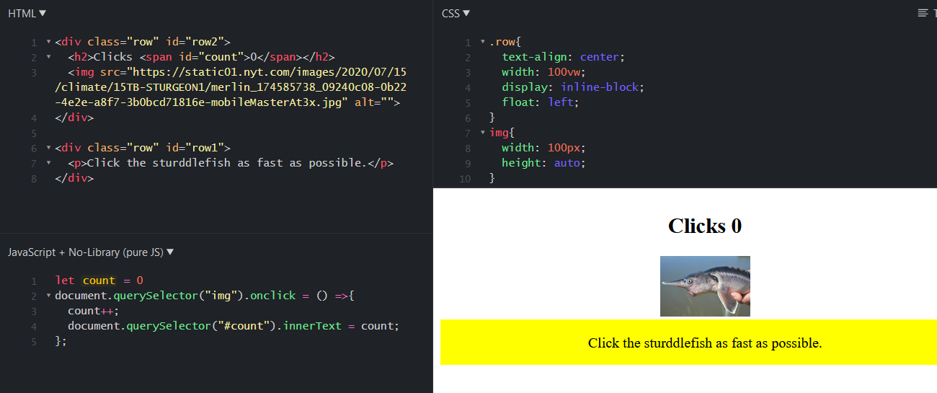

* What happens when you click the sturddlefish?
* Change the code so that count increments by 3 rather than 1:
* What css code is make row1 yellow?

|  |  |
| --- | --- |
| Row{background:yellow;} | .row{background: yellow;} |
| Div{background:yellow} | .div{background:yellow;} |
| #row1{background:yellow;} | #row2{background:yellow;} |

* Change the image of the sturddlefish to an image of a giraffe, paste a screenshot of the output below:

Part 2: Color

Part 2A: [Color Theory](https://www.w3schools.com/colors/colors_theory.asp)

1. Newton said colors are mixtures of which 3 kinds of light?

|  |  |
| --- | --- |
| Blue, orange, purple | Cyan, magenta, yellow |
| Black, white, gray | Green, blue, red |
| Red, blue, yellow | Blue, yellow, black |

1. Consider the following:

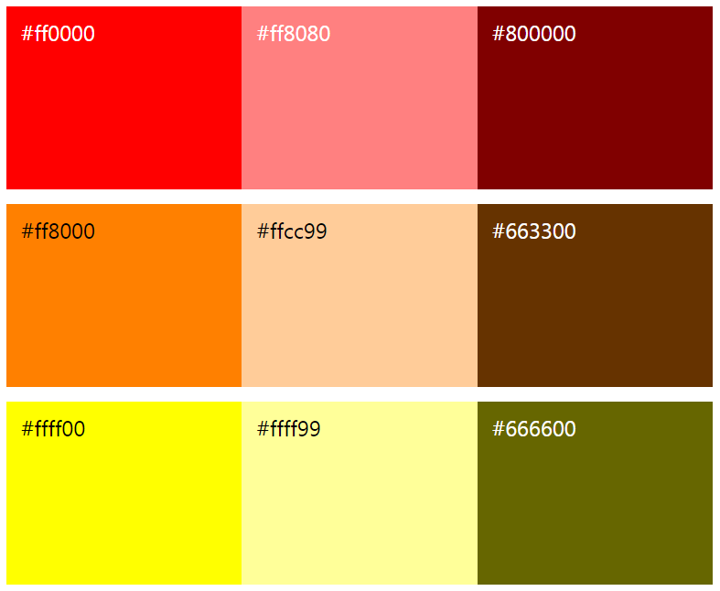

Which of the following has the same **hue** but different **darkness** than #ff0000?

|  |  |
| --- | --- |
| #ff8000 | #666600 |
| #800000 | #ff8080 |
| #ffcc99 | #663300 |

Part 2B: [Color Psychology](https://www.w3schools.com/colors/colors_psychology.asp)

1. Which color will most likely attract attention:

|  |  |
| --- | --- |
| Red | Blue |
| Green | Purple |
| Yellow | Brown |

1. All of the following are true of color except what?

|  |  |
| --- | --- |
| Influence taste of food | Influence attractiveness |
| Influence human behavior | Influence human height |

1. Which color should a spa use as the background color of their website? They want their users to feel *safe*, *calm*, and *fresh*.

|  |  |
| --- | --- |
| Black | Gray |
| Yellow | Green |
| Blue | Pink |

*Part 3: Design*

Use the following svg editor to complete the following: <https://www.drawsvg.org/drawsvg.html>

1. Create a logo for a basketball company called “Pro BBX Court”, paste a screen shot below:
2. Create an Image for the homepage of a pizza website, paste a screenshot below: